Summer Campus Bash
LEF/ARCADE Post‐Event Report

Submitted by: Students for Summer Fun (with collaboration from UA, GSC)
Contact: su28j@mit.edu
Main Acct Number: 1234567

Event date & time: July 12, 2008, 3‐8pm
Event location: Kresge
Approximate attendance: approx. 300
Non‐MIT student attendees: around 10

Funding board: LEF
Total expenditures: $1328.05
Funding allocation: $1500
Other funding sources: $100 (UA Fresh Fund)
Total to be transferred: $1228.05

Event Summary:

The event was a general success. We rented all of the Kresge BBQ pits and had the grill going for the entirety of the event as people were coming and going the entire time. Lots of games and sports items were also available for people to pass time: croquet, Frisbee, soccer. The idea of the event was to provide a low‐key atmosphere for the whole campus to get together once over the summer, both grads and undergrads. We think we definitely achieved that, and the GSC and UA help was crucial to reaching both sets of audiences.

The final attendance probably wasn’t as high as we had hoped. We were expecting close to 500. Part of that may have been publicity (we couldn’t get a general announcement out to the GSC list in time). There were also several other events going on the same day. We donated the leftover frozen foods to dorms.

Expenditures list:
Item | Budgeted Cost | Actual Cost | Notes
Grilling Supplies | $100 | $40.26
Charcoal | $50 | $40.26
Tools (spatula, scrub, tongs) | $50 | $0 | Borrowed from S&P
Sports Equipment/Games | $50 | $0 | Borrowed from various dorms/people
Croquet set | $20 | $0
Bocce set | $20 | $0
Frisbee | $10 | $0
Meat | $900 | $709.50
Frozen burgers | $600 | $449.70 | 30 packs of 20, $14.99 each
Hot dogs | $300 | $259.80 | 20 packs of 12, $12.99 each
Buns | $250 | $269.55
Hamburger buns | $150 | $149.75 | 25 packs of 20, $5.99 each
Hot dog buns | $100 | $119.80 | 20 packs of 20, $5.99 each
Drinks | $100 | $51.60
Juices | $60 | $0
Soda | $40 | $51.60 | 40 2L bottles, $1.29 each
Paper goods | $100 | $57.14
CAC rental | $200 | $200.00
Total | $1700 | $1328.05

Funding stipulations: LEF cut our budget to $1500 and limited our food expenditures to $1000, a request with which we have complied. We also saved money by borrowing reusables such as tools and games.

Promotional materials (note poster states "Sponsored by ARCADE")
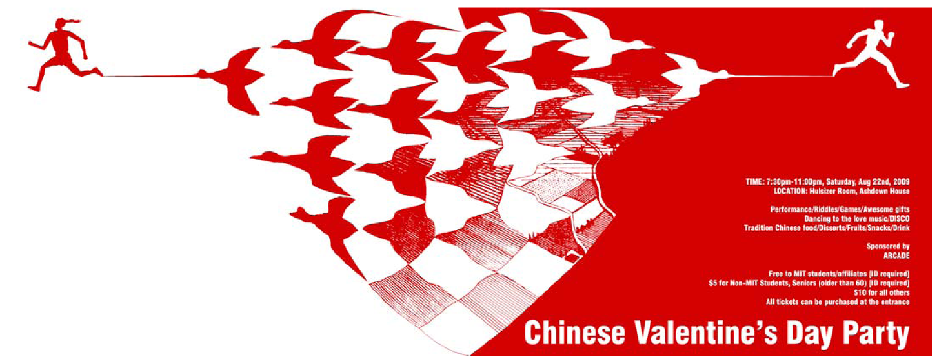

Event registration confirmation:


