An Investigation of Nuclear Reactors to Augment & Empower the
Unmanned & Manned Exploration of Mars

A Mission Strategy Overview and Preliminary Analysis of Potential Design Choices

Dr. Andrew Kadak
Vasek Dostal
Kalina Galabova
Knut Gezelius
Jack Horng
John Koser
Roshanak Nilchiani
Joseph E. Palaia, IV
Eugene Shwageraus
Pete Yarsky

Nuclear Engineering Department
Massachusetts Institute of Technology
Cambridge, MA

June 2003

Table of Contents

- Introduction
- Background
- Overview of Missions
  - Mars Nuclear Powered Telecommunications Satellite
  - Nuclear Powered Mars Surface Lander with ISRU, Sample Return, and Demonstration of the Mars Transfer System
  - ERV & Surface Hab Testing & Verification at International Space Station
  - Manned Mission: Concept Overview
  - Manned Mission: Launch Opportunity 1
  - Manned Mission: Launch Opportunity 2
  - Prospective on Continued Exploration
- Space Reactors for Electric Propulsion
  - Near Term Concept
    - Reactor Design
    - Propulsion System
  - Advanced Concept
    - Reactor Design
    - Propulsion System (VASMIR)
- Mars Surface Reactor
- Conclusion
- References

1) Introduction

  - Why Mars? (this should be short… just list a bunch of reasons already out there being used for substantiating Mars exploration).
  - Why is Nuclear an enabling technology for space exploration and especially for Mars exploration?
  - Many advantages of a power rich environment

Requirements and Constraints:
  - Demonstrate feasibility of nuclear powered space propulsion
  - Allow safe transport of humans to and from Mars
  - Expand the scientific capacity of individual missions
  - Reduce astronauts’ radiation exposure, especially due to GCR
  - Deployable by near term
  - The technology is transformational

Science Objectives of Mars Exploration:
  - Catalog the global distribution of life support, propellant, and construction materials (hydrogen, oxygen, nitrogen, phosphorous, potassium, magnesium, iron, etc.) on Mars.
  - Identify suitable venues at Mars, in the Martian system, and during Earth-Mars transits for new science measurements.
  - Using robotic and human investigations, gain significant insights into the history of the atmosphere, the planet’s geological evolution, and the possible evolution of life.

2) Background

  - Who we are
  - How we think we can help

Statement of Purpose:
Our intention is to form a plan for a series of Mars missions, leveraging the unique advantages provided by nuclear energy. Technological verification will allow subsequent capability expansion and finally for a manned mission to Mars.
3) Overview of Missions

  - Introduction to mission strategy
  - A plan for technological verification and capability expansion
for Mars Missions through the utilization of nuclear reactors.
- Launch window to Mars every two years (based on orbital alignment)
- Mars-Earth window goes through 15 year cycle, must plan system to work at worst case. It will yield improved performance at other opportunities.

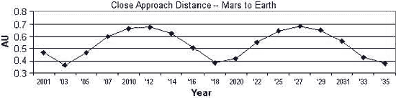

- It is desired to prove the viability of key components / systems of the eventual manned mission through the undertaking of a number of smaller missions.
- This breaks the technological development into smaller components, which are easier to get funding for.
- Validates technology & provides data for improvement of designs for use on manned mission.
- If a failure occurs, data is collected and steps are taken to fix the problem. The mission can be flow again until the problems are solved.
- Provides useful science data along each step, rather then committing a large amount of funding with no promise of science return unless/until the entire system works successfully.
- We have outlined below three precursor missions as well as the manned mission strategy.

3.a) Mars Nuclear Powered Telecommunications Satellite

  - First nuclear reactor powered Mars mission.
  - Could use systems similar to those developed for the Jupiter Icy Moons Orbiter.

Objectives:
- To provide capability for high data rate communications between Mars & Earth. Can provide data storage and relay for both Mars orbital and surface operations.
- To increase the science yield of all present and future Mars missions by allowing the transmission of more data.
- To validate space nuclear reactor technology, enabling this capability for future missions.
- To validate reactor powered electric propulsion technology for Earth-Mars transfer. (Scaled up versions of this reactor and propulsion system can be used for future Mars missions.)
- To provide a platform for high power Mars orbit experiments (active radar, etc.)
- To provide real-time orbital video and high resolution pictures.

Payload :
- High Transmitting Power (10-20kW) Telecommunications System
- Space Nuclear Reactor System (Producing 40kWe)
- Electrical Energy Conversion System (Thermal to Electrical)
- (EP) Electric Propulsion System
- EP Fuel (Xenon, etc.)
- High power experiments (radar, etc.)
- High resolution video and still camera system
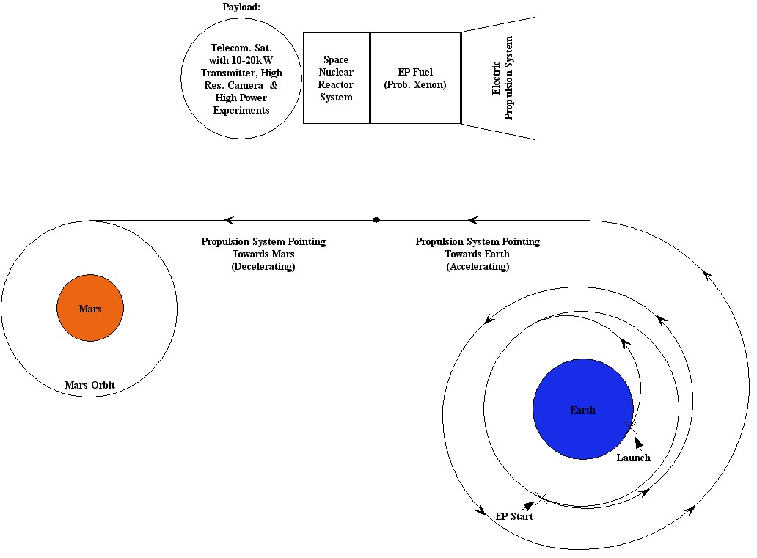

Mission Stage 1 (Launch to LEO):
- Payload is launched via a chemical rocket and placed in Low Earth Orbit.
- Chemical launch stage is jettisoned.

Mission Stage 2 (System Activation):
- EP system is deployed.
- Thermal Radiator system is deployed.
- Nuclear Reactor is activated.
- EP system is activated. This begins a slow spiral trajectory, building up velocity until the spacecraft leaves earth orbit.

Mission Stage 3 (Earth-Mars transfer & MOI):
- EP system propels the satellite halfway to Mars.
- Mid-journey the satellite reverses orientation.
- EP system slows the satellite into Mars orbit.

Mission Stage 4 (Early Mars Orbital Operations):
- The orbit is adjusted using the EP system to the point where a low polar orbit is achieved.
- This mapping orbit will allow the satellite to cross over most of the surface area of the planet. High-resolution video and pictures will be taken. Data will be collected from the high power experiments and relayed to Earth.

Mission Stage 5 (Late Mars Orbital Operations):
- Once a primary mapping mission is complete, the EP system will place the satellite in geo-stationary orbit over the location of a future surface mission. There it will be able to provide high data rate telecommunications capabilities.
- As other missions and communication needs change, the orbit can be maintained or adjusted through use of the EP system.

Note : It may be desirable to send a total of three or more telecommunications satellites to Mars orbit. This would allow non-stop communications capability between Earth and Mars as well as between virtually any two different locations on the planet surface. It also adds redundancy, should any one satellite fail. Collectively these satellites would be known as the (MTSS) Mars Telecommunications Satellite System.

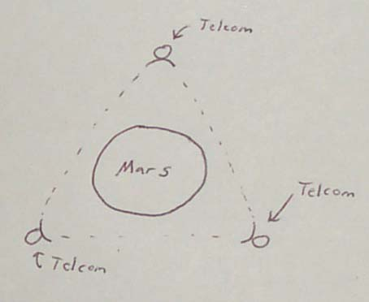
Figure : Three telecommunications satellites in Mars geo-stationary orbit. This configuration allows un-interrupted data transmission from virtually any location on the planet.

Remaining questions:
- What are the electrical propulsion requirements?
- What different experiments could make use of the high power level?
- What are the power demands of each of the suggested experiments?
- What power level should our nuclear reactor be?
- Should we include a small chemical rocket? Once the satellite has been pushed by the EP system beyond Earth orbit, it poses little risk to Earth should a failure occur. However, if a failure occurs while in LEO, a small chemical stage could push the satellite into a higher, more stable parking orbit. Alternatively, this stage can be used to capture into Mars orbit (rather than using the EP system). This could help conserve EP fuel for use later in the mission for orbital adjustments.

Our Technology Investigation for this Mission:
- Investigation of small scale space reactor & associated component design
- Investigation of EP system

3.b) Nuclear Powered Mars Surface Lander with ISRU, Sample Return, and Demonstration of the Mars Transfer System

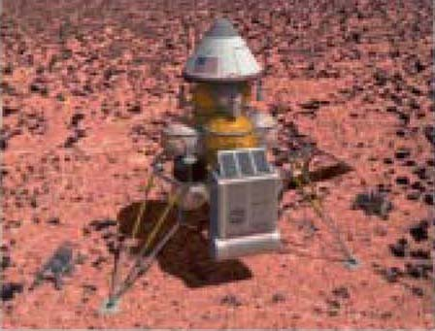
Objectives:
- To demonstrate the reusable Mars Transfer System (space reactor & refuelable EP system) for Earth to Mars cargo transfers.
- To validate Mars surface nuclear reactor technology, enabling this capability for future missions. This reactor will be identical to those to be sent on for the manned missions.
- To provide an energy recharging station to support surface rovers in sample collection.
    - The rovers will be able to operate day & night since they are not dependant on solar power. Also, rover operation is not dependant upon Earth-Mars relative orientations for data transmission. Data can be relayed / stored via either the nuclear powered base station or/and the Nuclear Powered Telecommunications Satellite.
    - Rovers and lander will not suffer from eventual failure due to dust build up on solar panels
    - Should provide increase range and mobility over solar powered rovers
- To collect a variety of samples from a selected area of the Martian surface.
- To validate large scale In-Situ Chemical Plant Technology (ISRU) by operating it on the surface of Mars and generating methane and oxygen largely from the CO₂ atmosphere. This enables this capability for future missions.
    - This is a proven technology on earth in Mars simulated conditions but never flown.
    - It depends on simple, 100 year old chemical processes.
    - Uses initial storage of hydrogen feedstock to generate oxygen, methane fuel, water, and oxygen.
- To fuel a sample capsule rocket with propellant and oxidizer produced from the Martian atmosphere and then use this rocket to launch these samples from the surface of Mars, putting them on a trajectory for Earth.
- To return selected samples of material from the surface of Mars to Earth for analysis.

Mars Transfer System (A scaled up version of the system from the first mission.):
- Space Nuclear Reactor System
- Electrical Energy Conversion System (Thermal to Electrical)
- Electric Propulsion (EP) System
- EP Fuel (Xenon, etc.)
- Docking mechanism (to dock with payload)

Payload:
- Aero capture shield for Mars orbital capture & for orbital entry.
- Surface landing system (retro-rockets, landing legs)
- Surface Nuclear Reactor System
- Electrical Energy Conversion System (Thermal to Electrical)
- (ISRU) In-Situ Resource Utilization System
- Hydrogen feedstock for ISRU system
- One or more rechargeable battery powered surface rovers.
- Sample return capsule with rocket (for ascent & TEI) and an empty fuel tank.
- Sample return capsule ablative heat shield (for Earth entry).

For this mission, since the surface reactor is identical to those to be sent on the manned missions, it’s size has been predetermined. We will also send the same quantity of hydrogen feedstock for this mission, thus the ISRU will produce the same amount of fuel and oxidizer as it would to fuel a manned ascent capsule. Based on this amount of fuel, the mass of samples that can be lifted off the surface of Mars and placed on a trajectory to Earth can be determined.

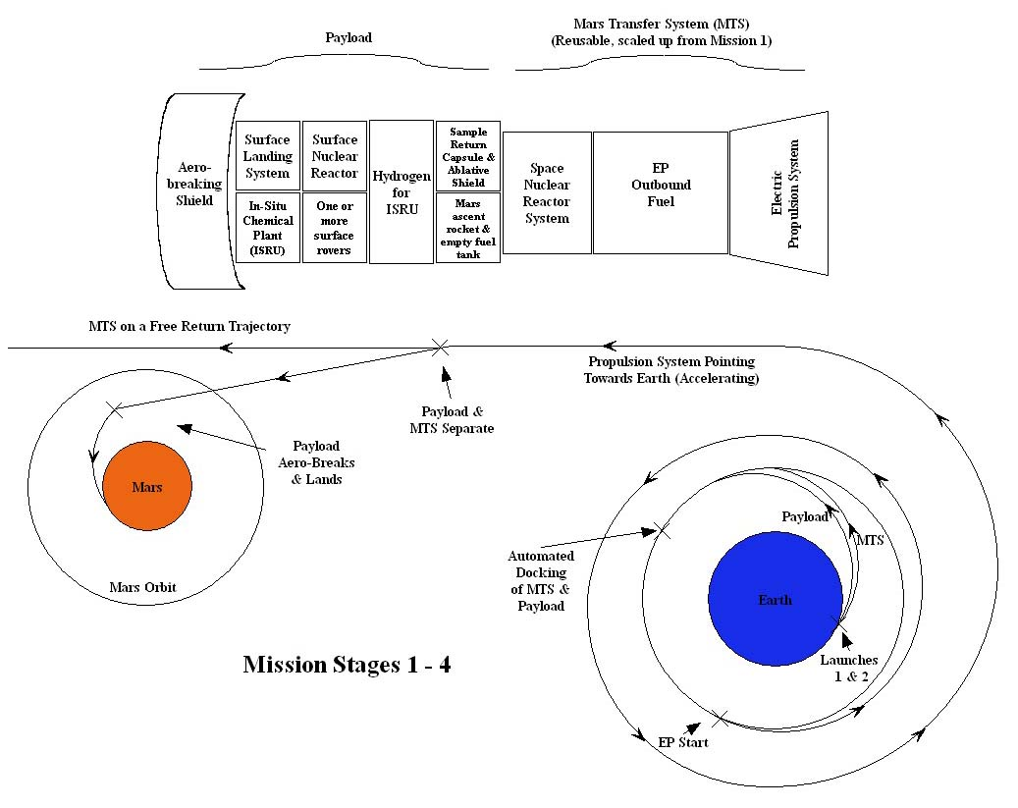 Mission Stage 1 (Launch):
- (Launch 1) Mars Transfer System is launched via a chemical rocket and placed in LEO.
- Chemical booster stage is jettisoned.
- (Launch 2) Payload is launched via a chemical rocket and also placed in LEO.
- Chemical booster stage is jettisoned.

Mission Stage 2 (MTS Activation):
- EP system is deployed.
- Thermal Radiator system is deployed.
- Nuclear Reactor is activated.
- EP system is activated.

Mission Stage 2 (Payload/MTS Docking):
- MTS rendezvous with Payload
- Automated docking performed between MTS and payload.

Mission Stage 3 (Earth-Mars transfer):
- MTS propels the payload partway to Mars.
- At a certain point, the MTS and Payload separate.
- MTS continues to fire as necessary to put it on a free return trajectory to Earth.

Mission Stage 4 (Aero Breaking & Landing)
- Payload aerocaptures/aerobreaks in the Martian atmosphere, slowing it down.
- Landing rockets slow the descent further to land the payload.

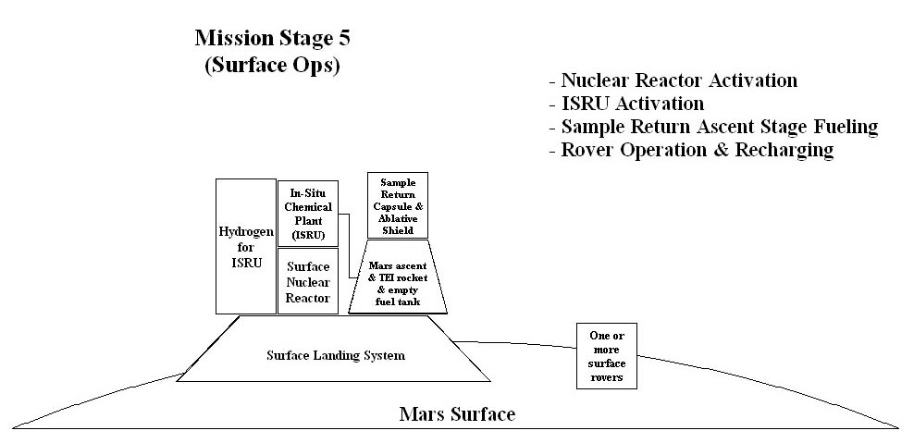

Mission Stage 5 (Base Activation & Operations)
- Thermal Radiators are deployed
- Nuclear Reactor is brought online.
- ISRU plant is activated and begins producing methane and oxygen.
- Rover is charged and deployed. It begins surface operations, locating and collecting samples. It returns and recharges as needed.
- Sample return rocket is fueled.
- Sample container is filled with samples.
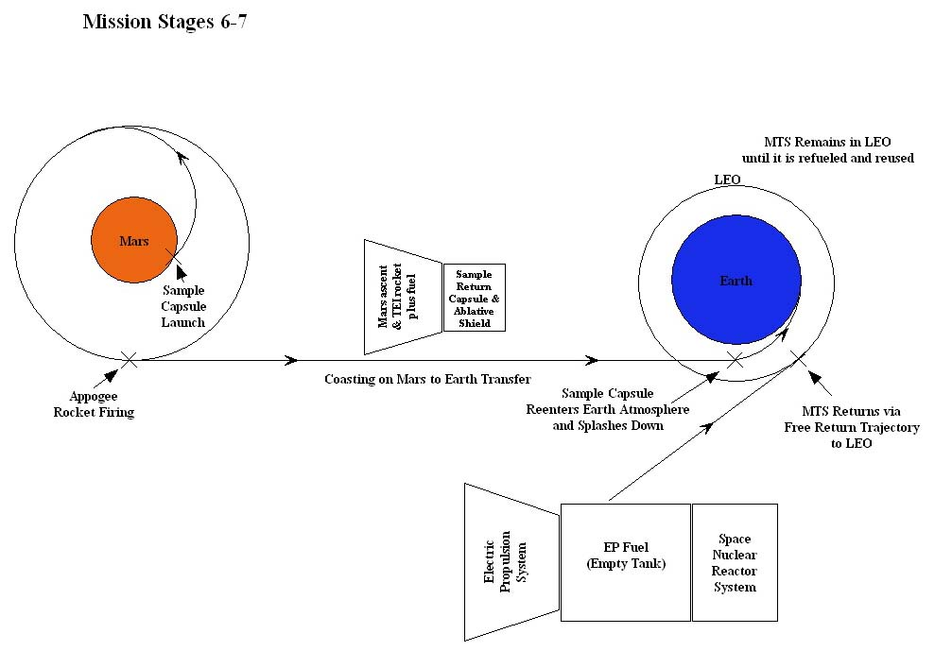

Mission Stage 6 (Ascent, TEI & Base Operations)
- The fully loaded and fully fueled sample return craft launches to Mars Orbit.
- Once reaching Mars orbit, the sample return craft uses the same ascent rocket to make an apogee firing to place it on a trajectory returning to Earth.
- The reactor and ISRU plant continue to operate on the surface until all available hydrogen feedstock has been exhausted. This can provide a small cache of backup consumables for future manned missions.
- The reactor will reduce it’s power output to the minimum necessary to supply energy to the rover(s). The rover(s) continue science operations until they or the reactor fail.
- This reactor and ISRU can serve as backup infrastructure for future manned missions.

Mission Stage 7 (Sample Entry and MTS Return)
- The Sample Capsule aero captures/breaks in the Earth atmosphere using its ablative heat shield. It splashes down or parachutes to a landing.
- The MTS returns to LEO via it’s free return trajectory. Here it can be refueled and reused.

Remaining questions:
- We need to clarify how the Mars Transfer System is used for this mission. It is my understanding that the MTS is used to propel the payload to Mars, but is itself on a free return trajectory (meaning it will return to earth orbit for reuse). Is this correct?
- How long does the MTS take to return to Earth on this free return trajectory?
- Does it make sense to do this?
- Does the MTS return to HEO or LEO (is it safe & sellable to the public to return it to LEO)? We need it in LEO to take advantage of it to send the next payload to Mars. If we have it return to HEO we need to somehow get it back down to LEO before we can reuse it. How do we get it back to LEO?

Our Technology Investigation for this Mission:
- Investigation of scaled up space reactor & associated component design
- Investigation of scaled up EP system
- Investigation of surface nuclear reactor design
3.c) ERV & Surface Hab Testing & Verification at International Space Station

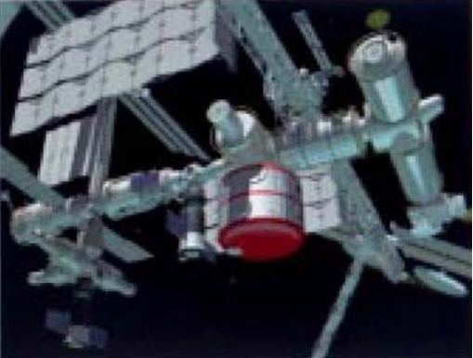

    - Provides testing of ERV & Hab design/operation prior to committing a human crew for the Mars transit.
    - Makes use of current infrastructure and capability (ISS).
    - This hab could remain at the ISS and greatly expand the living space aboard the station.
3.d) Manned Missions: Concept Overview

Our plan for manned missions is to use the NASA Reference Mission and optimize it with the addition of Nuclear reactors both in space and on the surface of Mars.
- we are using the NASA Reference Mission Ver. 3.0 Addendum to define many of our mission requirements and payload masses. We are also assuming a surface reactor power of 200kWe, a slight adjustment to the reference mission’s 160kWe.
- unlike the NASA Reference Mission, we are not using an NTR system for the Trans-Mars Insertion. Instead, we have created the Mars Transfer System (MTS), which is a reusable, nuclear powered electric propulsion system.

Objectives:

- Land people on Mars and return them safely to Earth.
- Balance technical, programmatic, mission and safety risks.
- Provide an operationally simple mission approach emphasizing the judicious use of common systems.
- Provide a flexible implementation strategy.
- Limit the length of time that the crew is continuously exposed to the interplanetary space environment.
- Define a robust planetary surface exploration capacity capable of safely and productively supporting crews on the surface of Mars for 500 to 600 days each mission.
- Define a capability to be able to live off the land. This means developing effective system designs and processes for using in-situ materials to replace products that otherwise would have to be provided from Earth.
- Rely on advances in automation to perform a significant amount of the routine activities through the mission.
- Ensure Infrastructure is operational before a crew is committed
- Ensure that management techniques are available and can be designed into a program implementation that can substantially reduce costs.
- Manage space operations capabilities including communications, data management, and operations planning to accommodate both routine and contingency mission operational situations; and understand abort modes from surface or space contingencies.
- Use the Earth-Mars launch opportunities occurring from 2007 through 2014. A 2009 launch represents the most difficult opportunity in the 15-year Earth-Mars cycle. By designing the space transportation systems for this opportunity, they can be flown in any opportunity with either faster transit times for the crew or increased payload delivery capacity.
- Examine three human missions to Mars. The initial investment to send a human crew to Mars is sufficient to warrant more than one or two missions. Each mission may return to the site of the initial mission or establish a new site within roving distance of the other site(s). Thus there can be an evolutionary establishment of capabilities on the Mars surface.
- Identify the characteristics of space transportation and surface operations systems consistent with sustaining a long-term program at affordable cost.

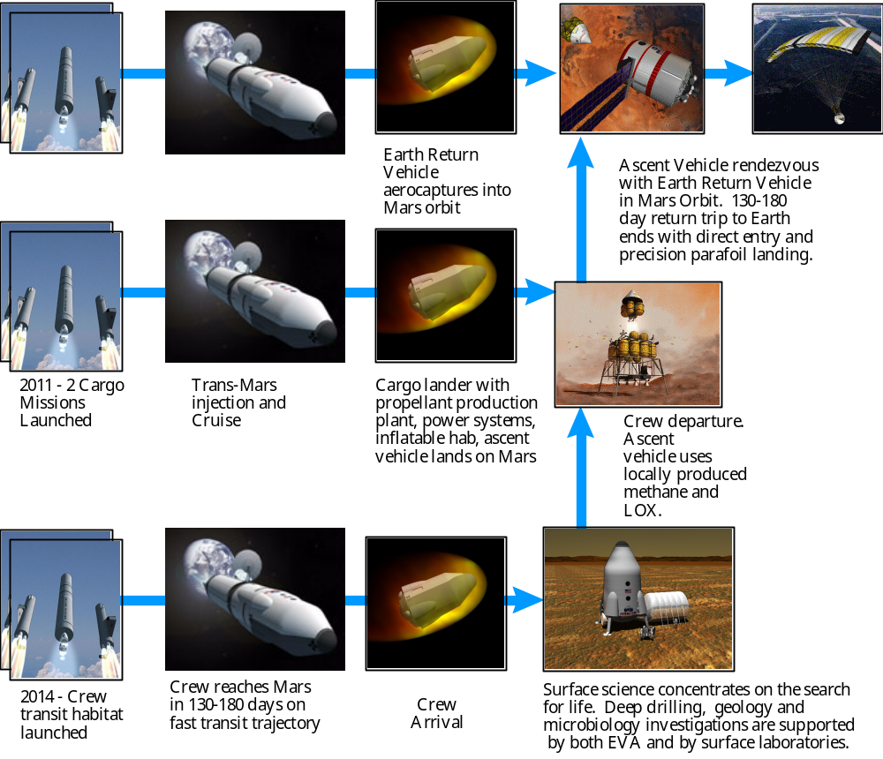

Figure : Basic Mission strategy to be followed. Graphic taken from the NASA Reference Mission Ver. 3.0 Addendum report.

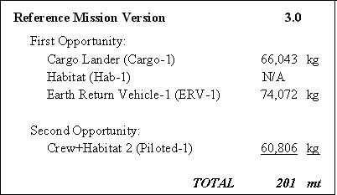

e) Manned Missions: Launch Opportunity 1
- this could be as soon as 2012

Four Magnum heavy launches (~80 tons max capacity ea) take place and send 2 payloads and 2 Fueled MTS stages to LEO. The MTS stages rendezvous with the payloads in LEO. The Mars Transfer System stages then propel them on to Mars.

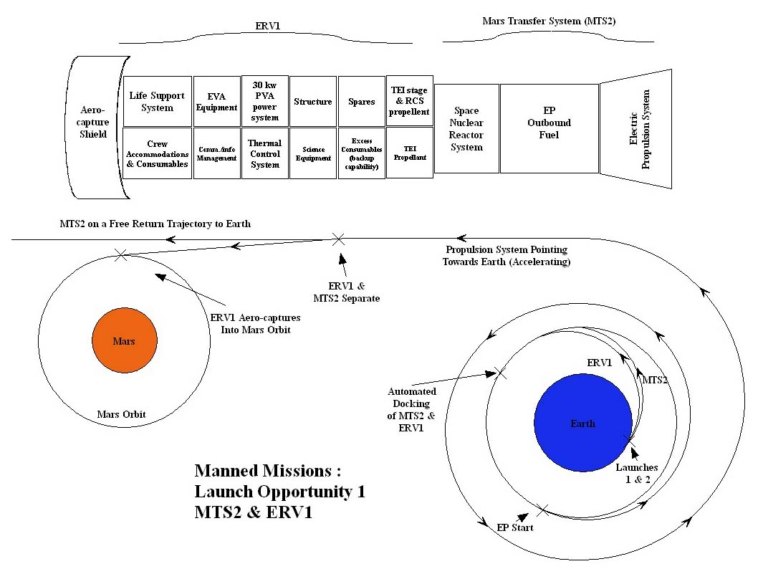
1st Launch
- MTS2 for ERV1
- EP propellant (Xenon)

This docks with Earth Return Vehicle 1 and propels it to Mars.

2nd Launch

- Earth Return Vehicle 1, which includes
- Trans-Earth Injection (TEI) stage
- Return fuel
- Return habitat

This is the earth return vehicle that will remain in Mars orbit until the crew is ready to return to Earth.
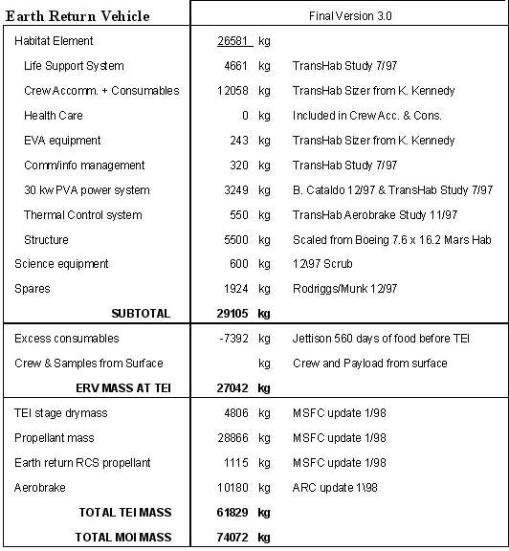
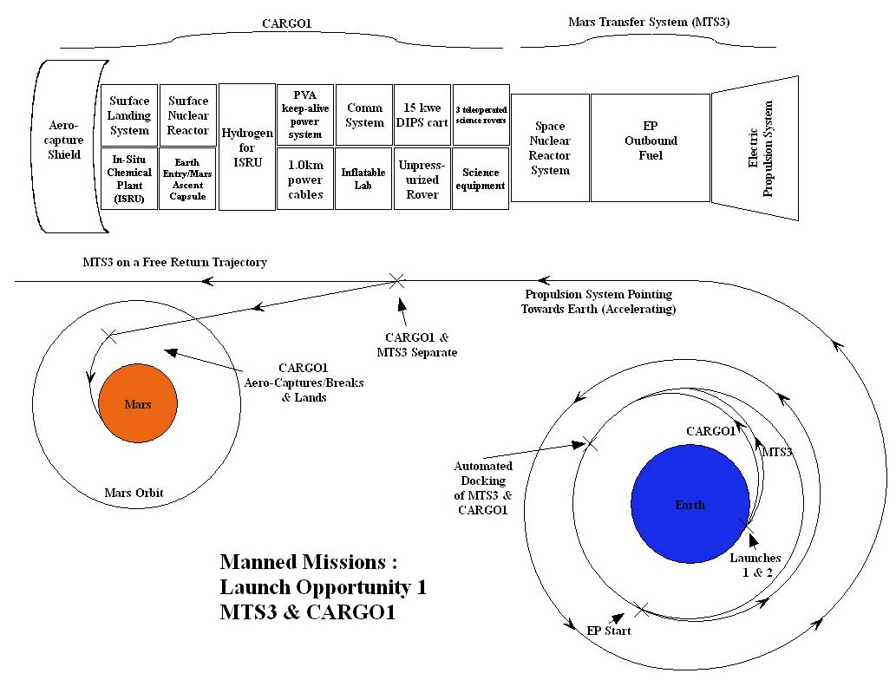
3rd Launch
- MTS3 for Cargo Vehicle 1
- EP propellant (Xenon)

This docks with Cargo Vehicle 1 and propels it to Mars.

4th Launch
- Cargo Vehicle 1 stage which includes
- aero shield
- descent stage/landing system
- Earth Entry/ Mars Ascent Capsule
- ISRU Plant
- Hydrogen Feedstock for ISRU
- Surface Nuclear Plant on mobile truck (to wheel the plant 1km away from
everything else)
- 1 km long power cables
- Surface communications system
- Inflatable mars surface labs
- Un-pressurized rover
- Water storage tank
- Science equipment

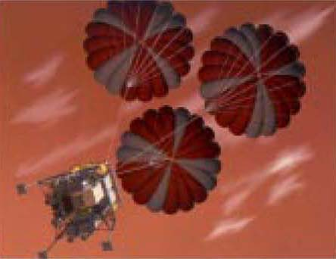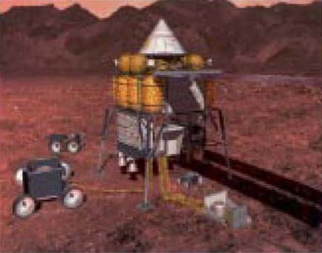

This is the main shipment of cargo to the Martian surface. It will aerocapture/aerobreak for a landing on Mars. Then it will start up the nuclear reactor & ISRU, fueling the ascent capsule and begin generating oxygen and water for life support systems. These will all be up and running before the human crew is committed.

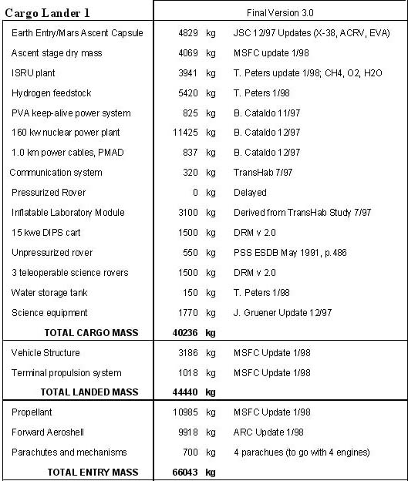

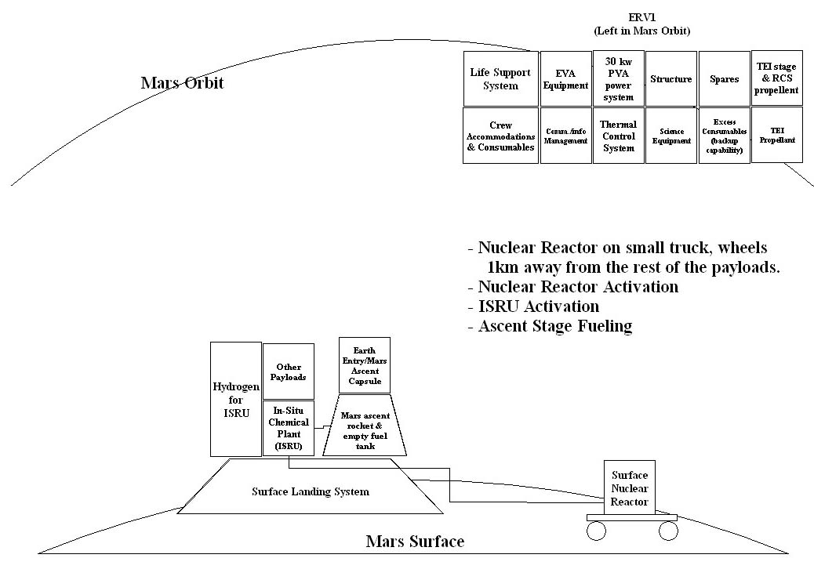

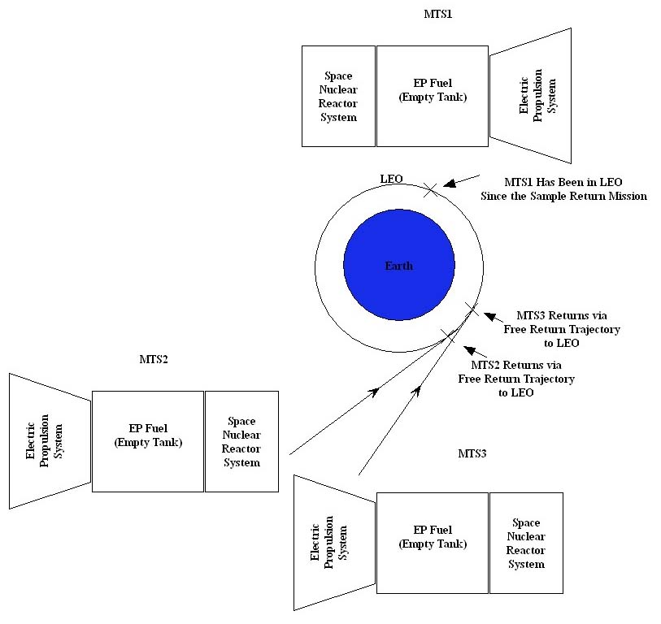
3.f) Manned Missions : Launch Opportunity 2
- this could be 2014

Four Magnum heavy launches (~80 tons max capacity ea) take place and send 3 payloads, and one MTS refueler to LEO. The refueler breaks into three sections, which rendezvous with MTS1, MTS2 & MTS3. These Mars Transfer Systems are now ready to be reused. The three Mars Transfer Systems rendezvous with the payloads in LEO. After the Crew Habitat Vehicle 1 (CHV1) spirals from LEO to HEO by the MTS, the crew launch on a small shuttle (CS1). They rendezvous with CHV1 in HEO. The MTS stage then propels them on to Mars.

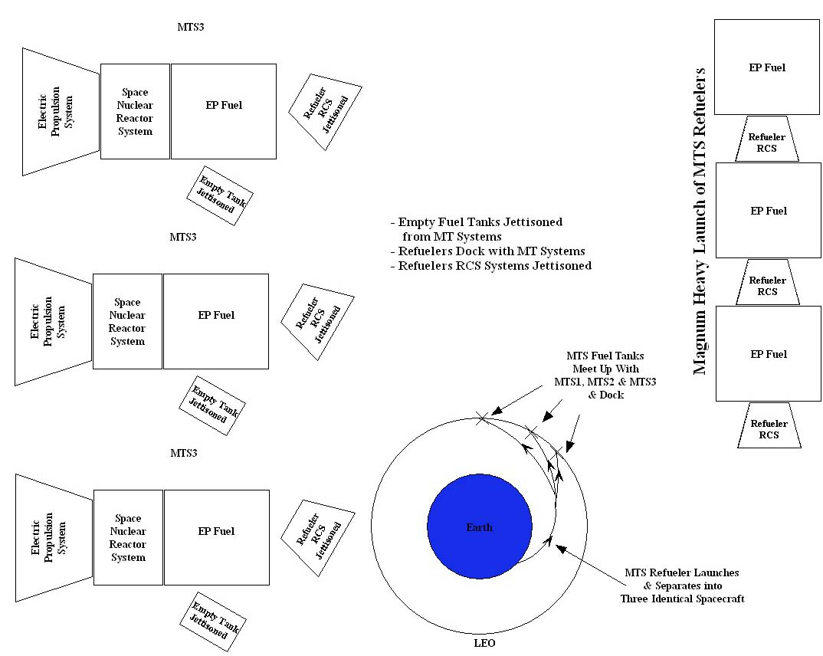
1st Launch
- MTS Refueler which separates into three identical sections each containing:
- Fuel tank containing a max of 25 tons of Xeon fuel
- RCS system for orbital maneuvers
- Docking system (to dock with MTS)
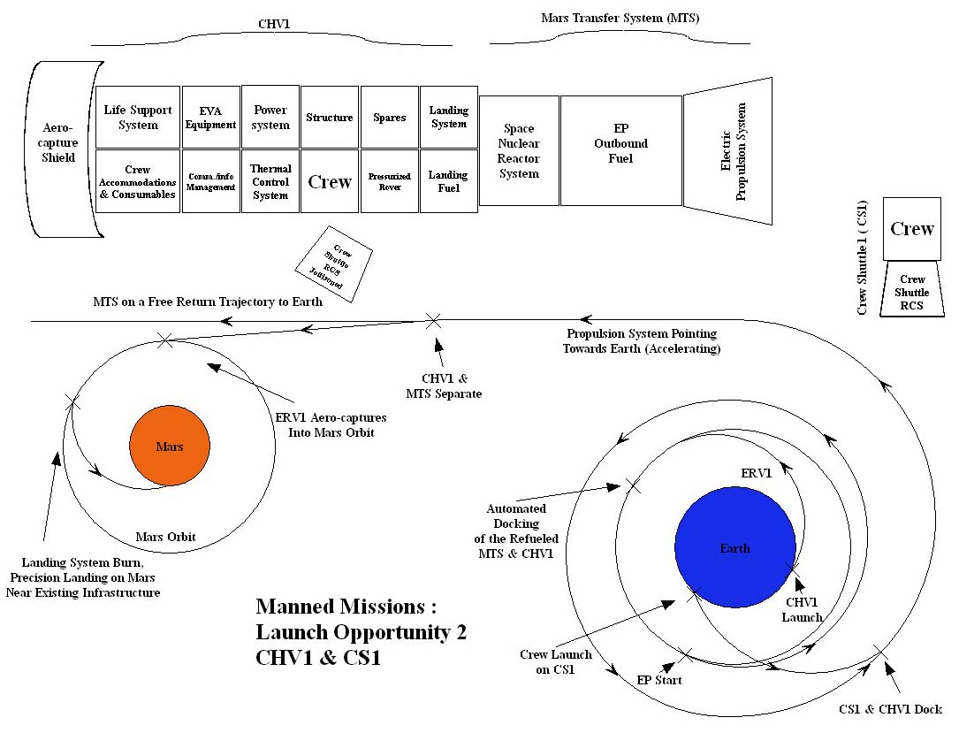
2nd Launch
- Crew Habitat Vehicle 1 (CHV1) which includes
- Habitat
- Life support system
- crew accommodations
- EVA equipment
- Comm/info management
- Power system
- Thermal system
- structure
- science equipment
- spares
- Pressurized rover
- EVA consumables
- EVA suits
- aero shield
- descent stage

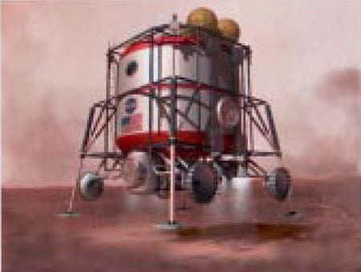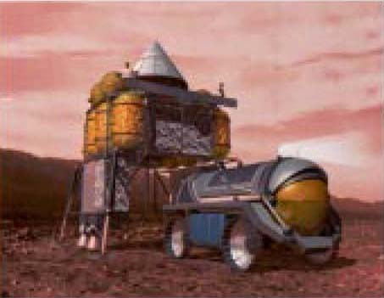

This delivers the crew & their surface habitat (which is what they live in for the Earth to Mars journey as well) to Mars. There they will land near their cargo from the 2nd launch of 2011. They will conduct their surface operations for 600 days or so, then climb into the Earth Entry/Mars Ascent capsule. They will launch and meet the ERV and TEI stage in Mars orbit, which will propel them back to Earth. When they get to Earth, they will make a direct Apollo style splashdown in their capsule.

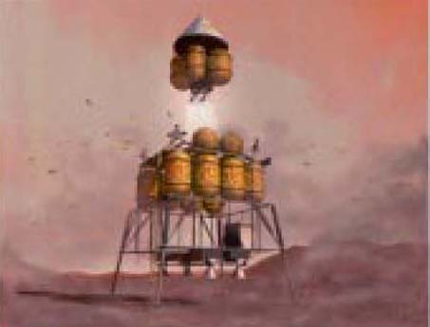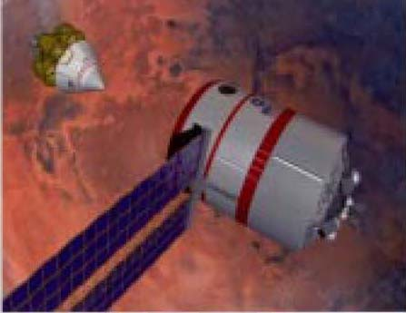

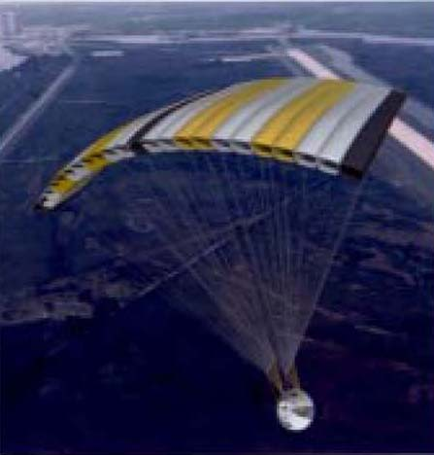
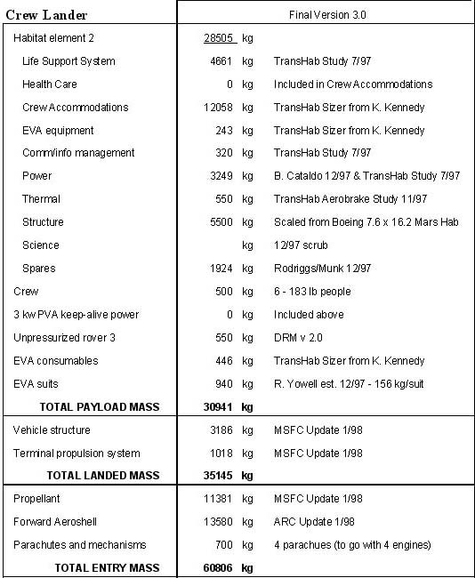

3rd Launch
- Earth Return Vehicle 2 (ERV2), identical to the 2nd launch of 2011

This can either serve as a backup ERV for the first crew, or the primary ERV for the second crew.

4th Launch
- Cargo Vehicle 2 (CARGO2), identical to the 4th launch of 2011

This can either serve as a backup Cargo for the first crew, or the primary cargo for the second crew.

5th Launch
- Crew Shuttle 1 (CS1)

This delivers the crew to CHV1 in HEO. Up to this point, there has been no risk to the crew. They are being delivered to a full fueled and operational vehicle. The propulsion system for this vehicle (MTS) has been operating well for some time, pushing CHV1 from LEO to HEO. The crew is delivered at this point, as opposed to in the initial launch of the CHV, for a number of reasons. The path the CHV takes going from LEO to HEO passes through large portions of the high radiation Van Allen belts. Astronauts traveling through these belts for any length of time would be subjected to intense radiation. Also, this reduces other requirements such as life support.
When the crew arrives at Mars, they will instruct the CARGO2 unmanned craft to land a certain distance away from the initial lander. This will provide them with a larger landing ellipse for their craft. They will have a better chance of landing close to either of the CARGO landers. Should there be a problem with the first set of infrastructure/ERV then the second set will serve as a backup. The astronauts can transfer to the backup set of infrastructure via their pressurized rover should the first set fail. Assuming no infrastructure failure occurs, by the time they are ready to return to earth, the backup ERV will be fully fueled. If not used by this crew, it will serve as the primary ERV for the second crew.

3.g) Prospective on Continued Exploration

Every two years, four magnum heavy launches and one low mass crew shuttle launch send infrastructure and crew to continue a sustained Mars exploration program. Each successive mission adds redundancy on the surface and increases the overall mission success rate.
The Magnum heavy launches would send an ERV, a CARGO payload, and a CHV (Crew Hab Vehicle) to Mars at each launch opportunity. The three Mars Transfer Systems (MTS) would be refueled via the fourth Magnum heavy launch. This reusable system substantially reduces the requirements to continue Mars exploration, by replacing three Magnum launches (for three new TMI stages) with one magnum refueling launch at every launch opportunity. Over a ten-year period of continuous Mars exploration this would account for a savings of 10 Magnum launches!
4. Space Reactors for Electric Propulsion

4.a) Near Term Concept
4.a.i) Reactor Design

4.a.ii) Propulsion System

4.b) Advanced Concept
4.b.i) Reactor Design

4.b.ii) Propulsion System (VASMIR)

5. Mars Surface Reactor

- blah

6. Conclusion

–Each mission builds off technology demonstrated in previous missions
–Essential Infrastructure is developed and deployed on Mars to support further human exploration

7. References

The Reference Mission of the NASA Mars Exploration Study Team. Editors Stephen J. Hoffman, David L. Kaplan. NASA. Lyndon B. Johnson Space Center, Houston, TX. July, 1997.

Reference Mission Version 3.0 Addendum to the Human Exploration of Mars. The Reference Mission of the NASA Mars Exploration Study Team. Offices of Exploration & Advanced Development. NASA. Lyndon B. Johnson Space Center, Houston, TX 77058. June, 1998.

Zubin, Robert & Richard Wagner. The Case for Mars. New York. The Free Press. 1996. ISBN 0-684-82757-3

To Be Done To This Section:
- Addition of more references
- Formatting of references to meet appropriate publication standards.

