CS 112 How to write, save and then run a program file in python:
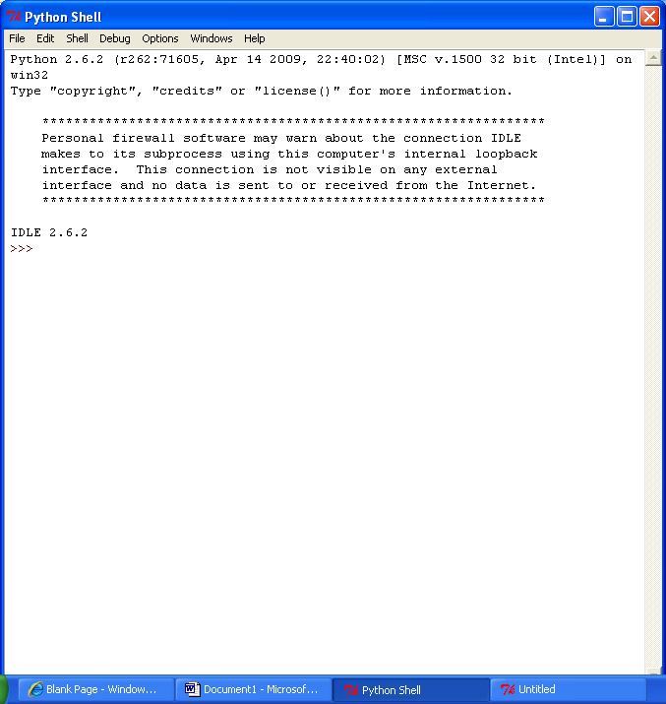
- Start IDLE.

- Open a new editable file window in IDLE by choosing FILE→ New Window from a *Shell* window.

- Write your program.
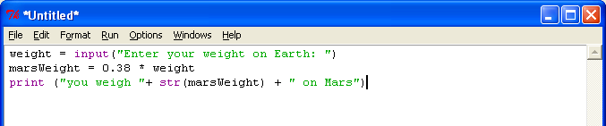
- Save it as something.py (here marsWeight.py) in a folder that you can find later. I recommend that you have a folder on your Y: drive for all your CS 112 programs.
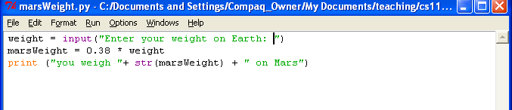
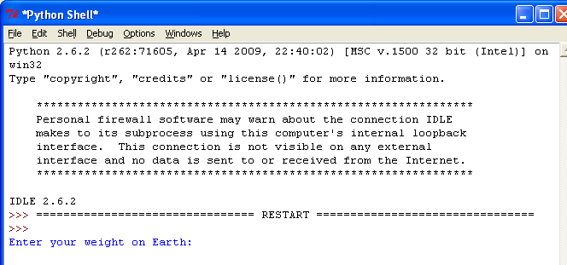
- Select Run→ Run Module (or just hit F5) and a new Shell window will open. (why do they call these Shells? Long answer; not interesting) It will also start your program running. Any print-outs to the screen are written in the shell.

- Now, switch roles from being the omniscient programmer (author of the program) to the end user and follow directions. Hit <ENTER> after you type in any info. The program runs!
